PRESS RELEASE

For more information contact:
Ballet Des Moines
Jami Milne, Creative Director
515-32`-7054
jami@balletdesmoines.org

Kevin Jenison
Communication Manager
Public Information Officer
Muscatine City Hall
(563) 264-1550
kjenison@muscatineiowa.gov

FOR IMMEDIATE RELEASE
JULY 27, 2022

GRAVITY ON TOUR LANDS IN MUSCATINE THIS SUNDAY
Ballet Des Moines returns to provide a dance and educational experience for all

MUSCATINE, Iowa – Ballet Des Moines will bring its full company of professional dancers to Muscatine this Sunday, sharing world-class arts and education programming directly with patrons of all ages in a one-of-a-kind day of fun activities.

The free performance will take place in the green space south of the basketball courts in Riverside Park. The 7 p.m. performance will be preceded by free family STEM activities inside Pearl City Station from 5 to 7 p.m. Be sure to come early, bring your blankets or lawn chairs, and sit back to enjoy the entertainment.

Everyone is invited to come explore a mobile planetarium, Iowa State University's FLEx Virtual Reality lab, send a postcard to space, and investigate other STEM activities while exploring how the universal language of music and movement can make abstract concepts more human and accessible.

Gravity on Tour includes excerpts from Ballet Des Moines’ ground-breaking GRAVITY season along with a host of interactive STEM experiences, from Iowa State University’s FLEx Virtual Reality Lab and the Science Center of Iowa's mobile planetarium to sending postcards to space and back. These free performances build on the April 2022 world premiere of the interdisciplinary ballet Of Gravity and Light, exemplifying how music and movement can make abstract concepts more human and accessible to audiences of all ages.

Ballet Des Moines CEO Blaire Massa worked with community leaders statewide to determine tour locations, ensuring a strong sense of collaboration with tailored opportunities specific to the interests and values of each community.

“We’ve worked diligently for the past several months to ensure we’re delivering on our community engagement, outreach, and education initiatives — to expand access to the arts, while wielding creativity and expression as a tool to expand learning, build confidence, and forge community connections,” says Massa. “From educational workshops and in-person ballet classes to meet-and-greets with the artists, pop-up planetariums, and young professional cocktail parties, there’s no shortage of opportunities to collaborate and inspire curiosity, confidence, and creativity across our state.”

STEM partners throughout the 21-22 season have included the NASA Iowa Space Grant Consortium (ISGC) and Iowa State University.

“Working with Ballet Des Moines this year has allowed us to introduce students to activities that help support our objectives at ISGC, to help inspire, educate, and employ the next generation of explorers,” says director Dr. Sara Nelson. “It’s been wonderful to watch as students learn more about the connections between science and art and how dance can be used to express those understandings.”

Each performance will include excerpts from BDM’s GRAVITY season, highlighting a diverse range of programming including this spring’s world premiere Of Gravity and Light, a pas de deux from Swan Lake, and Flight, a joy-filled contemporary ballet by Ballet Des Moines Artistic Director Tom Mattingly. In between the evenings performances, NASA Solar System Ambassadors will guide the audience through scientific discussions.

Gravity on Tour was made possible by Principal Foundation and the Iowa Arts Council. Additional details about the tour can be found at www.balletdesmoines.org/summer-tour

FREE FAMILY-FRIENDLY STEM ACTIVITIES 5-7PM

Enjoy a mobile planetarium, Iowa State University's FLEx Virtual Reality lab, send a postcard to space, and investigate other STEM activities while exploring how the universal language of music and movement can make abstract concepts more human and accessible.


SCI programming reaches every county in the state of Iowa, promotes cultural awareness and provides unique experiences for Iowans. The broad range of available opportunities — from Science @ Your Site, which offers a variety of assemblies and demonstrations at schools, libraries and festivals, to professional development training that advance STEM literacy and bring innovative activities to educators statewide — speaks to the many roles SCI plays for the community and is the foundation upon which SCI has built a successful organization.

Centrally located in Downtown Des Moines, SCI's hands-on exhibits, special-format theaters and unique programming attract Iowans and distant visitors. Through daily visitors, a statewide educational outreach program and the NAEYC-accredited SCI Preschool, the Science Center of Iowa serves more than 300,000 people annually.
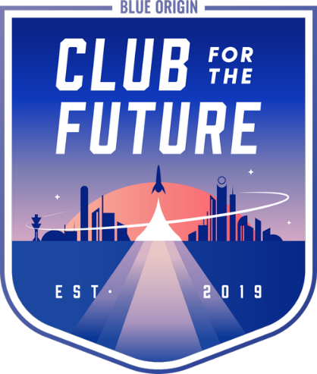
Founded by Blue Origin in 2019, Club for the Future is a foundation whose mission is to inspire future generations to pursue careers in STEM and to help invent the future of life in space. The Club and its collaborators are doing this through Postcards to Space, space-focused curriculum, and access to space on Blue Origin’s rockets.

Earth is finite. To protect our gem of a planet and enable a future of abundance and growth, Earth needs space. Write or draw your vision on a postcard for what you think the future of life in space will look like—or any other message you’d like to send to space. Write or draw on a provided postcard to Club for the Future, we'll launch it to space and back on a New Shepard rocket, and return it to you stamped "Flown to Space." Send us as many postcards as you'd like—we'll fly them all.


FLEx is a mobile learning program for advanced design technology benefiting 3rd through 12th students and beyond in a 21st century paradigm. Structured around STEM, design thinking, 21st Century skills, and University Constructs (4 C’s), this environment extends distant educational offerings by delivering full-scale augmented and virtual visualization, digital to real prototyping, circuit bending and visual programming.
As an Iowa State design outreach program for Iowans, the FLEx can visit classrooms, schools, libraries, science and art centers, educational conferences and other community events throughout the state. Programs can be offered inside or outside, weather permitting, to best complement the learning environment and event.


A part of NASA’s National Space Grant College and Fellowship Program since 1990, the ISGC continually strives to improve and inspire Iowa’s future in Science, Technology, Engineering and Math (STEM). The ISGC supports aerospace research, education and outreach activities for all Iowans with NASA internships, fellowships, and scholarships, competitions for grants within higher education members (with NASA Mission Directorate alignment), as well as informal education grants with outreach affiliates. The ISGC is primarily funded under NASA Award No. 80NSSC20M0107.

About Ballet Des Moines

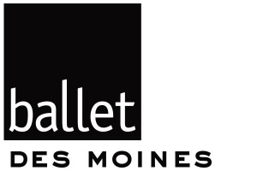
Ballet Des Moines was launched as a professional ballet company in 2012, bringing world-class performing artists to the Des Moines community for classical and contemporary main stage productions. Ballet Des Moines offers training opportunities for pre-professional dancers and engages thousands of local youth each year through rich educational and outreach programs. The mission of Ballet Des Moines is to enrich lives through inspiring dance performances, inclusive education and outreach programs, and innovative community partnerships. www.balletdesmoines.org

About the Iowa Space Grant Consortium

A part of NASA’s National Space Grant College and Fellowship Program since 1990, the ISGC continually strives to improve and inspire Iowa’s future in Science, Technology, Engineering and Math (STEM). The ISGC supports aerospace research, education and outreach activities for all Iowans with NASA internships, fellowships, and scholarships, competitions for grants within higher education members (with NASA Mission Directorate alignment), as well as informal education grants with outreach affiliates. The ISGC is primarily funded under NASA Award No. 80NSSC20M0107. https://www.iaspacegrant.org

###

